**BIS Graduation Project**

|  |
| --- |
|  |
| Egypt Banks |
| Project No **(111)** |
| **Team Members** |
| |  |  | | --- | --- | | **Name** | **Id** | | **1. Karim Khaled Shoaib Morayef** | **18190497** | | **2. Ali Marawan Hassan Hassan** | **18190429** | | **3. Ahmed Abdelelah gaber Sotohy** | **18190030** | | **4. Omar Salah El din mohamed abdelalem** | **18190447** | | **5. Nour El Deen abdelkareem gamal** | **18190993** | | **6. Ahmed Amr AbdelGawad Mohamed** | **18190116** | |
|  |
| **Supervisors** |

**IT Business**

**Dr: Shereen Taie Dr: Nagwa Elbeheiry**

**Acknowledgement**

Table of Contents

CHAPTER ONE: INTRODUCTION 6

**1.1 System Overview:** 6

**1.2 Project Background:** 6

**1.3 Problem definition:** 6

**1.4 Project Objectives:** 6

**1.**5 **Project scope:** 7

**1.6 System Users** 7

**1.7.1 In design section**: 8

**1.7.2 In development section**: 8

**1.7.3 In database section** 9

**1.7.4 Hardware** 10

**1.7.4 Software:** 10

**1.8 Features** 11

**1.9 Methodology and time plan** 13

CHAPTER TWO: BUSINESS MODEL 16

**2.1 Executive Summary** 16

**2.2 Mission** 18

**2.3 Vision** 18

**2.4 Business Idea and Market** 18

**2.5 Existing competitors:** 19

**2.6 Marketing Research and survey** 20

**2.7 Marketing Plan Product** 24

**2.8 Marketing Plan Price** 24

**2.9 Marketing Plan Promotion** 25

**2.10 Legal Form** 26

**2.11 Start-Up Capital** 27

**2.12 Sources of Start-Up Capital** 28

**2.13 Organization and Staff** 30

**2.14 Business Operation and Costs** 31

**2.15 Cash Flow Plan** 33

**2.16 Profit Margin** 34

**2.17 Opening Balance** 35

**2.18 SWOT** 36

CHAPTER THREE: SYSTEM ANALYSIS 38

**3.1. Introduction:** 38

**3.2 Requirements gathering:** 38

**3.2.1 User requirements:** 39

**1.3** **Usecase diagram** 43

**1.4** **Sequence diagram** 43

44

CHAPTER FOUR: SYSTEM DESIGN 47

**4.1 Introduction** 47

**4.2 ERD** 48

**4.3 Activity diagram** 49

**4.4 Class Diagram** 52

**4.5 Sitemap** 53

CHAPTER FIVE: SYSTEM IMPELENTATION 54

**5.1 Introduction to System Implementation** 54

**5.2 Screenshots of user interface** 55

CHAPTER SIX: SYSTEM TESTING 59

**6.1 Testing scenario** 59

**1.2** **Testing coding** 60

CHAPTER SEVEN: CONCLUSION &FUTURE WORK 76

**7.1 Conclusion:** 76

**7.2 Future Plans:** 77

REFERENCES 79

**Websites References:** 79

**Books references:** 80

# **CHAPTER ONE: INTRODUCTION**

## **1.1 System Overview:**

It is a site that serves to facilitate banking operations between customers and banks..

## **1.2 Project Background:**

we made a website that serves customers in facilitating their banking operations with banks and their employees.

Through our application

Any Client can:

* Login/Register
* View all banks and banks details
* View and compare bank tariffs
* View and compare bank offer
* Book bank visit
* View CBE news
* View and book bank treasury
* Log out

## **1.3 Problem definition:**

Many people suffer from the crowding of banks, the difficulty of communicating with customer service, the lack of awareness of the operations that take place within the bank, and it is sometimes difficult to complete banking operations successfully, so we made a website that serves customers in facilitating their banking operations with banks and their employees.

## **1.4 Project Objectives:**

Our site gives the possibility for people to take an interest in riding a calf and encourage them to do so. Through the site, people can:

* View all banks and banks details
* View and compare bank tariffs
* View and compare bank offers
* Book bank visit
* View CBE news
* View and book bank treasury.

## **1.**5 **Project scope:**

Our Scope will be inside Egypt Starting with Cairo launching our Service with reliability, flexibility, and ease for the Customer.

## 

## **1.6 System Users**

**Client :**

* Login/Register
* **View all banks and banks details**
* **View and compare bank tariffs**
* **View and compare bank offers**
* **Book bank visit**
* **View CBE news**
* **View and book bank treasury**
* **Log out**

**Admin**

* Login
* Add and edit bank info
* Add and edit bank tariffs
* Add and edit bank offers
* Add and edit CBE news
* Add and edit treasury

**1.7 system requirements:**

Requirements mean all languages and tools we need to run our project, it consists of three categories; design, development, database.

### **1.7.1 In design section**:

**Languages**

**HTML**

HTML stands for Hyper Text Markup Language, HTML is the standard markup language for creating Web pages, HTML describes the structure of a Web page, HTML consists of a series of elements, HTML elements tell the browser how to display the content

**CSS**

CSS stands for Cascading Style Sheets, CSS describes how HTML elements are to be displayed on screen, paper, or in other media, CSS saves a lot of work. It can control the layout of multiple web pages all at once, External style sheets are stored in CSS files

**Tools**

**Notepad ++**

Available only for Windows users, Notepad ++ is a free source code editor written in C++. Its user interface (UI) is completely customizable, and users can decide how syntax is highlighted and folded.

### **1.7.2 In development section**:

**Languages**

**PHP**

* PHP is a server scripting language, and a powerful tool for making dynamic and interactive Web pages.
* PHP is a widely-used, free, and efficient alternative to competitors such as Microsoft's ASP.

**Tools**

**Apache HTTP Server** is a free and open-source web server that delivers web content through the internet. It is commonly referred to as Apache and after development; it quickly became the most popular HTTP client on the web.

**Zend Studio** is an IDE that takes PHP development to the next level. It has a robust set of features and can deploy to any server including servers in the cloud.

### **1.7.3 In database section**

**Languages**

**SQL**

* SQL stands for Structured Query Language
* SQL can execute queries against a database
* SQL can retrieve data from a database
* SQL can insert records in a database
* SQL can update records in a database
* SQL can delete records from a database
* SQL can create new databases
* SQL can create new tables in a database
* SQL can create stored procedures in a database
* SQL can create views in a database
* SQL can set permissions on tables, procedures, and views

**Tools**

**MySQL**

* MySQL is a database system used on the web
* MySQL is a database system that runs on a server
* MySQL is ideal for both small and large applications
* MySQL is very fast, reliable, and easy to use
* MySQL uses standard SQL
* MySQL compiles on a number of platforms
* MySQL is free to download and use

### **1.7.4 Hardware**

The most common set of requirements defined by any operating system or software application is the physical computer resources, also known as hardware, A hardware requirements list is often accompanied by a hardware compatibility list (HCL), especially in case of operating systems. An HCL lists tested, compatible, and sometimes incompatible hardware devices for a particular operating system or application. The following sub-sections discuss the various aspects of hardware requirements.

### **1.7.4 Software:**

Software requirements deal with defining software resource requirements and prerequisites that need to be installed on a computer to provide optimal functioning of an application. These requirements or prerequisites are generally not included in the software installation package and need to be installed separately before the software is installed.

|  |  |
| --- | --- |
| System requirements | |
| Operating system | [Windows 2000](https://en.wikipedia.org/wiki/Windows_2000)/[XP](https://en.wikipedia.org/wiki/Windows_XP) |
| CPU | [Pentium 4](https://en.wikipedia.org/wiki/Pentium_4) 1.5 GHz or [Athlon XP](https://en.wikipedia.org/wiki/Athlon_XP) 1500+ processor or higher |
| Memory | 384 MB [RAM](https://en.wikipedia.org/wiki/Random_Access_Memory) |
| Free space | 2.2 GB free space |
| Media | 8x Speed [CD-ROM](https://en.wikipedia.org/wiki/CD-ROM) |
| Graphics hardware | 3D Hardware Accelerator - 64MB of memory minimum DirectX 9.0b |
| Sound hardware | [DirectX](https://en.wikipedia.org/wiki/DirectX) 9.0b compatible 16-bit [sound card](https://en.wikipedia.org/wiki/Sound_card) |

## **1.8 Features**

* The system allows the customer to choose the appropriate spare parts for his cars
* The system allows providing insurance on the car for the customer
* The system allows the provision of mechanics in the nearest place to the customer for maintenance work
* The system allows providing all the services available in the cars, in order to serve the customer..

## **1.9 Methodology and time plan**

The Waterfall Model was the first Process Model to be introduced. It is also referred to as a linear sequential life cycle model. It is very simple to understand and use. In a waterfall model, each phase must be completed before the next phase can begin and there is no overlapping in the phases.

The Waterfall model is the earliest SDLC approach that was used for software development.

Advantages of the Waterfall Model are as follows−

* Simple and easy to understand and use

* Easy to manage due to the rigidity of the model. Each phase has specific deliverables and a review process.

* Phases are processed and completed one at a time.

* Works well for smaller projects where requirements are very well understood.

* Clearly defined stages.

* Well understood milestones.

* Easy to arrange tasks.

* Process and results are well documented.

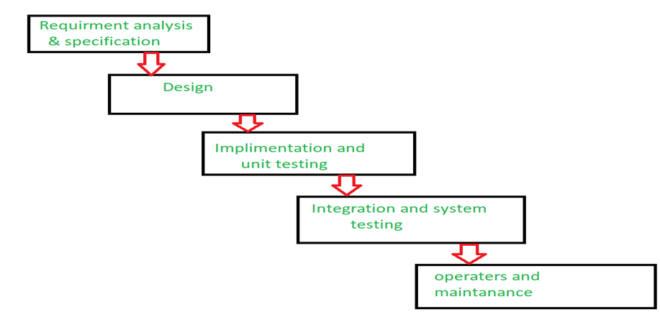

**CHAPTER TWO: BUSINESS MODEL**

## **2.1 Executive Summary**

**Name of business Egypt banks**



**Legal form General Partnership [GP]**

**Contact address 21-Hassan Mamoen - Street- Egypt**

=م

|  |  |  |  |  |  |  |  |  |  |
| --- | --- | --- | --- | --- | --- | --- | --- | --- | --- |
| **Mobile: +20 10109494850** | |  |  | **E-mail** | **Egypt banks998@gmail.com** | | | |  |
|  |  |  |  |  |  | |  | | |
| **Type of business** | |  | **Service Provider** | |  |  | |  | | |
| **Manufacturer** ✔ | |  | **Service**  **provider** | | **Wholesaler** | | **Retailer** | | |



**Brief description of the business idea**

* It is a site that serves to facilitate banking operations between customers and banks

**Owner(s)**

**Number of jobs to be created 6 jobs**

**Start-up capital**

**Investment EGP 30,000**

**Working capital EGP 350,000**

**Total EGP 380,000**

**Source of capital**

**Own savings**

**Partner EGP 280,000**

**Family loan EGP 100,000**

## **2.2 Mission**

**What do we do?**

* we made a website that serves customers in facilitating their banking operations with banks and their employees.

**Whom do we serve?**

* Serves all people that deal with banks

**How do we serve them?**

Through our application

Any Client can:

* Login/Register
* View all banks and banks details
* View and compare bank tariffs
* View and compare bank offer
* Book bank visit
* View CBE news
* View and book bank treasury
* Log out

## **2.3 Vision**

**What are our hopes and dreams?**

* Serves all people that deal with banks by facilitating banking operations between customers and banks

**What problem are we solving?**

* Many people suffer from the crowding of banks, the difficulty of communicating with customer service, the lack of awareness of the operations that take place within the bank, and it is sometimes difficult to complete banking operations successfully, so we made a website that serves customers in facilitating their banking operations with banks and their employees.

**Who and what are we inspiring to change?**

The change is that our site facilitates banking operations between customers and banks

## **2.4 Business Idea and Market**

**Description of the business idea**

Our site gives the possibility for people to take an interest in riding a calf and encourage them to do so. Through the site, people can:

* View all banks and banks details
* View and compare bank tariffs
* View and compare bank offers
* Book bank visit
* View CBE news
* View and book bank treasury.

## **2.5 Existing competitors:**

**Alliant Credit Union**

**Website:**[**https://www.alliantcreditunion.org/**](https://www.alliantcreditunion.org/)

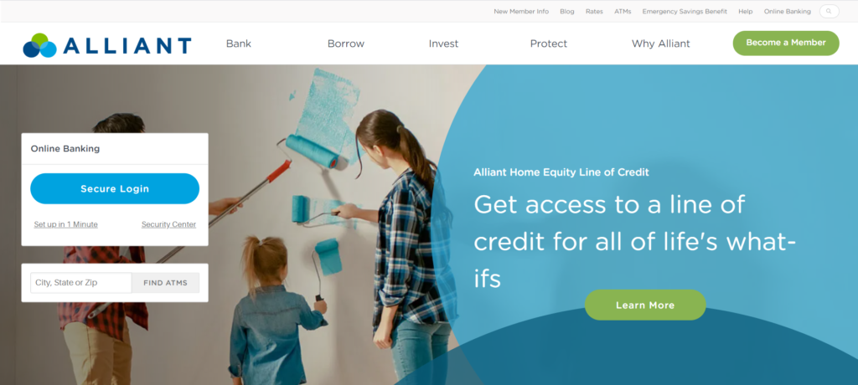

**This is one of our top picks for a good reason. From the moment you arrive on the homepage, this website establishes trust and authority while guiding users to the information they need. Clean and simple navigation, clear calls-to-action for members and non-members, an eye-catching monthly payment savings calculator right on the homepage, links to helpful blog articles, real customer testimonials, and ample contact information. All these elements work together to create a pleasant and informative experience.**

.

**Ally**

**Website:**[**https://www.ally.com/**](https://www.ally.com/)

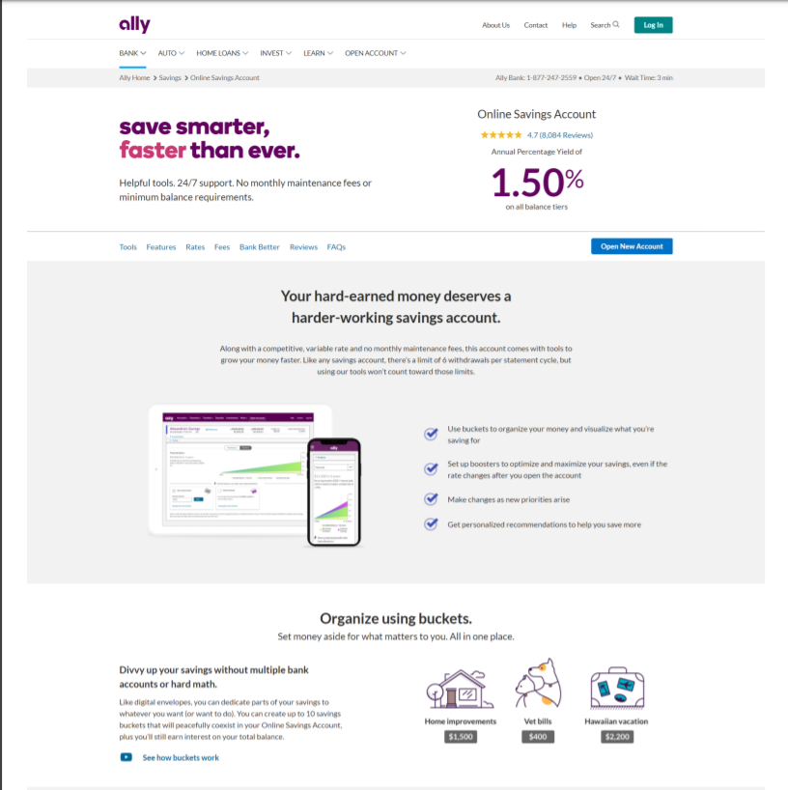

**When engaging in Search Engine Optimization and Pay-per-Click advertising, your users are primarily going to arrive on your site via your internal pages. With that in mind, let’s take a look at Ally’s**[**personal savings account**](https://www.ally.com/bank/online-savings-account/)**page. Imagine that you just clicked on an ad to open a personal savings account, and this is the page you’ve landed on. Right away, you can see the APY, valuable features, excellent user reviews, and a link to open an account. Scrolling further down the page, we’re given even more information about rates and earnings compared to their top competitors, a clear breakdown of fees, frequently asked questions, and a few reasons why Ally is different from other FIs.**

**BBVA Compass**

**Website:**[**https://www.bbvacompass.com/**](https://www.bbvacompass.com/)

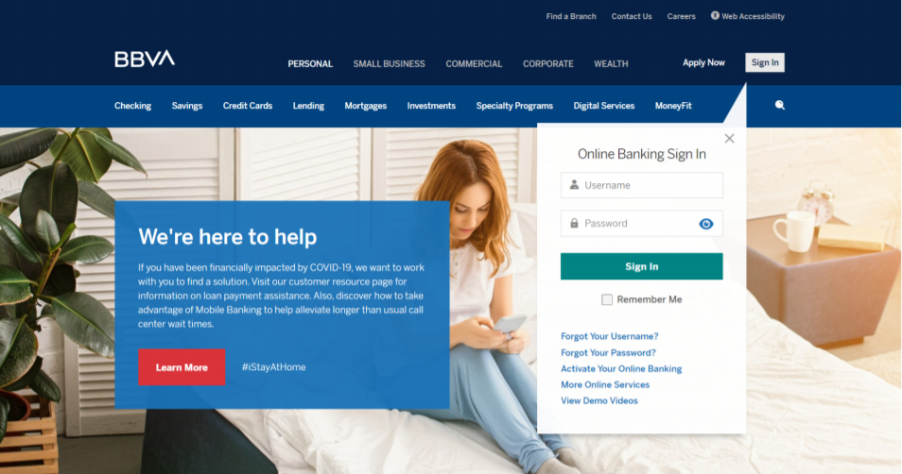

**BBVA Compass offers a wide array of financial services for a varied audience, which can make it difficult to maintain a clean and easy navigation. However, this site offers a clear visual hierarchy that funnels users into the appropriate section of their website, allowing them to find the information they need quickly and easily. On top of this excellent navigation experience, the site offers links to helpful blog articles (unique pieces of content, rather than syndicated articles from financial websites), and provides multiple avenues for users to get in touch with them.**

**The Florist Federal Credit Union**

**Website:**[**https://www.thefloristfcu.org/**](https://www.thefloristfcu.org/)

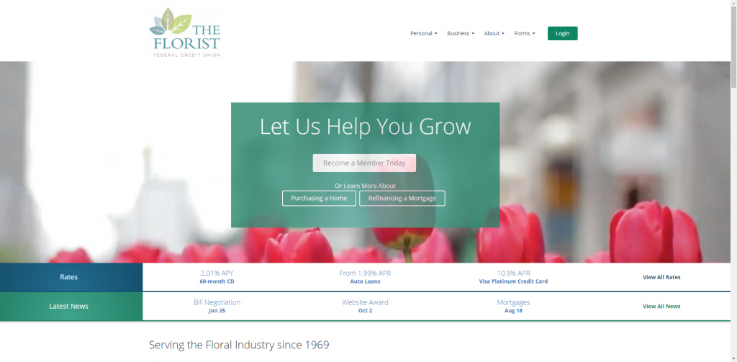

**Here’s something a little different – a federal credit union that serves the floral industry. Despite having such a niche audience, this website provides an exceptional user experience. The homepage is designed to convert potential members, offers a clean and uncluttered navigation, provides rate information directly on the homepage, and differentiates this credit union from other financial institutions. The internal pages follow the clean, streamlined design of the homepage. While these pages don’t feature elements we’ve seen on other websites (user reviews, loan calculators, FAQs), these pages give users an adequate amount of information and clear conversion points**

**Live Oak Bank**

**Website:**[**https://www.liveoakbank.com/**](https://www.liveoakbank.com/)

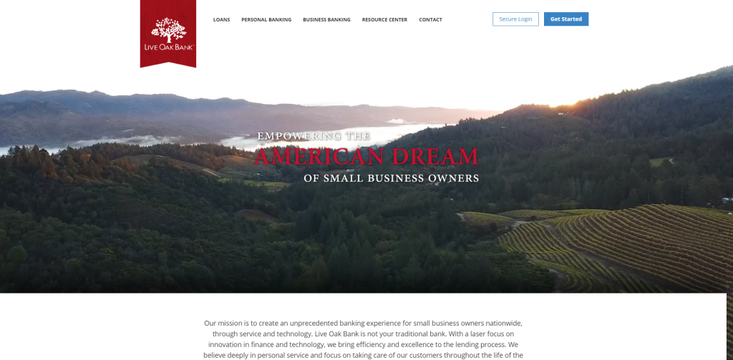

**The Live Oak Bank website takes a minimalist approach with a focus on providing the most valuable information to their visitors. Loan rates, savings interest rates, contact information and calls-to-action all help drive visitors deeper into the website while providing an informative and transparent experience. Product pages are educational, build credibility by containing glowing customer reviews, and help differentiate Live Oak Bank from their competitors**.

## **2.6 Marketing Research and survey**

In our website, we deal with all the people, because our website, and the website is based on dealing with all people, we have made survey in Arabic and English in order to facilitate people and benefit from a lot of opinions

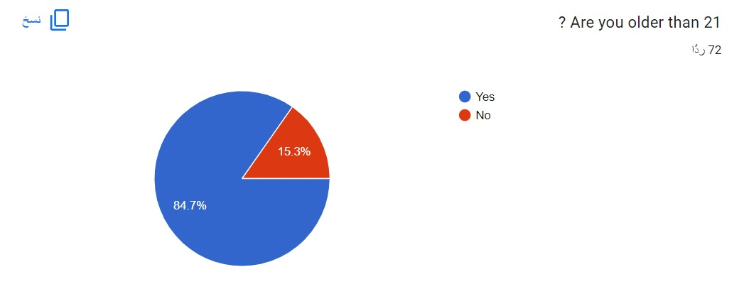

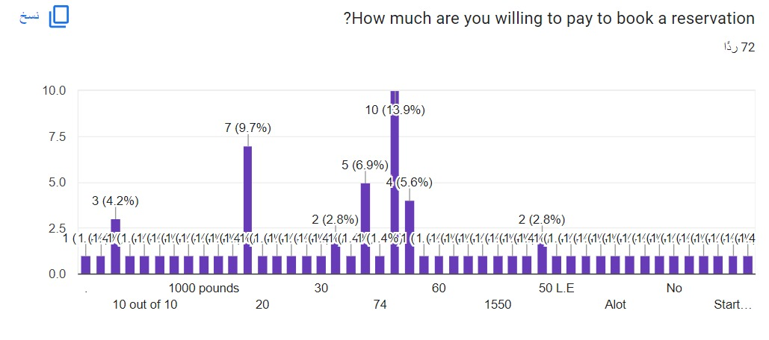

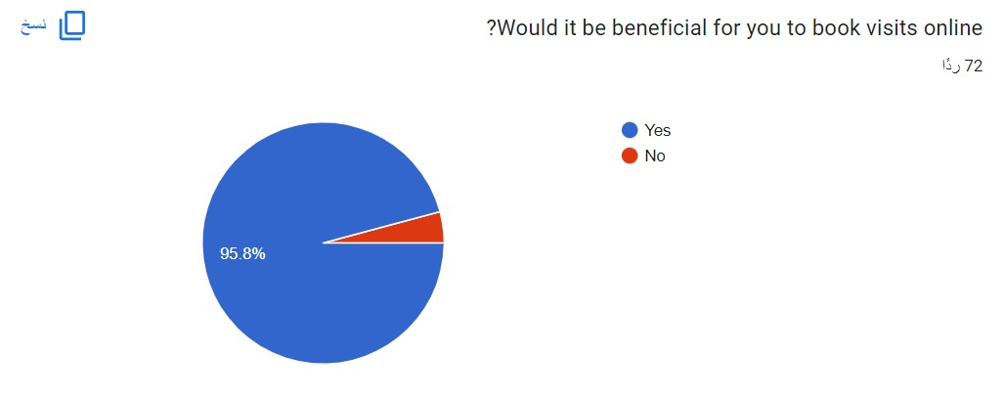

## 

## 

## **2.7 Marketing Plan Product**

**&**

## **2.8 Marketing Plan Price**

|  |  |  |  |
| --- | --- | --- | --- |
| **Details/Service** | **1-** **Book a visit to the bank** | **2-Buy normal AD** | **3-Buy Premium AD** |
| Description | If any Client want to book a visit to the bank, can pay fees and book a visit. | Any Client, or merchant want to market himself through our site can pay money and increase his views via our application | Any Client, or merchant want to market himself through our site can pay money and increase his views via our application |
| Type of fees | Certain amount of fees per booking | Certain amount of fees | Certain amount of fees |
| Duration | - | 1 Month | 1 Month |

|  |  |  |  |
| --- | --- | --- | --- |
| Details/Service | **1-** **Book a visit to the bank** | **2-Buy normal AD** | **3-Buy Premium AD** |
| How much are clients willing to pay? | EGP 20 | EGP 5,000 | EGP 15,000 |
| Competitors’ price | 40 | 7,500 | 20,000 |
| My price | EGP 20 | EGP 5,000 | EGP 15,000 |
| Reasons for setting my price | To Meet Customer Needs | To Meet Customer Needs | To Meet Customer Needs |

## **2.9 Marketing Plan Promotion**

**Start-up promotion**

Our Start up promotion will be 3 months containing our AD, link and data on Facebook, and Instagram

|  |  |  |
| --- | --- | --- |
| **PLANNED Marketing Campaign Cost** | | |
| **place** | **Ad Cost/ Month** | **AD Cost per 3 Months** |
| Facebook | EGP 2,000 | EGP 6,000 |
| Instagram | 2,000 | 6,000 |
| **Total Ads Cost** | **4,000** | **12,000** |

## **2.10 Legal Form**

**The legal form of the business will be: A General Partnership**

**Reason for choosing this legal form:**

* The business risk is diversified among the partners which motivates the owners to be more aware of the work done and lower the errors and risks into minimal.
* The partnership helps in processing new and diversified ideas and brainstorming which support the continuity of productivity and higher the chances of success and survival.

* The partnership agreement template defines the roles and contributions of the partners

.

* The agreement for partnership includes terms for how profits will be divided, the responsibilities of the partners, how to manage the partnership, & how decisions will be made.
* A buy-sell agreement is used to control what happens to the business partnership ownership & management if a partner sells their share, resigns, dies, or becomes incapacitated in the future.
* Partnerships can offer tax advantages by allowing income to be taxed at the partner's individual tax rate, rather than corporate rates.



## **2.11 Start-Up Capital**

|  |  |  |
| --- | --- | --- |
| **Estimation of start-up capital [EGP]** |  | **Amount [EGP]** |
| **INVESTMENT** | | |
| Equipment | 30,000 |  |
| **Total Investment** | | **30,000** |
| **Working Capital** | | |
| 12 Months Salaries | 270,000 |  |
| Rented apartment | 60,000 |  |
| 3 Months of marketing | 12,000 |  |
| Subscriptions | 4,000 |  |
| Web app needs | 4,000 |  |
| **Total working Capital** | | **350,000** |
| **TOTAL START-UP CAPITAL** | | **380,000** |

**Specification of investment items**

|  |  |  |
| --- | --- | --- |
| **Investment item** | **Specification** | **Price [EGP]** |
| **Equipment** | **pcs used for the staff** | **30,000** |
| **TOTAL ACQUISITION COSTS** | | **30,000** |

## **2.12 Sources of Start-Up Capital**

**Sources of funding**

|  |  |  |  |
| --- | --- | --- | --- |
| **Type** | **Source** | **Conditions**  **(Duration/interest)** | **Amount** |
| **Equity capital** | **✔ Partners** | **EGP 46,667 of each partner to build the start up with 0 interest** | **280,000** |
| **Loan 1** | **✔ Family** | **3years family Loan with 0% interest rate and the first instalment will be in the second year of operation.** | **100,000** |
| **TOTAL FUNDING** | | | **EGP 380,000** |



## **2.13 Organization and Staff**

**Organization of the business**

**Staff costs**

|  |  |  |
| --- | --- | --- |
| **Position** | **Salary per month** | **Total Annual staff cost** |
| **Accountant** | **3,750** | **45,000** |
| **Market research analyst** | **3,750** | **45,000** |
| **Human resource manager** | **3,750** | **45,000** |
| **Computer programmer** | **3,750** | **45,000** |
| **Auditor** | **3,750** | **45,000** |
| **System analyst** | **3,750** | **45,000** |
| **Total Staff Cost [EGP]** | **22,500** | **270,000** |



## **2.14 Business Operation and Costs**

**Monthly Sales Plan**

**The following numbers doesn`t include our first free visit.**

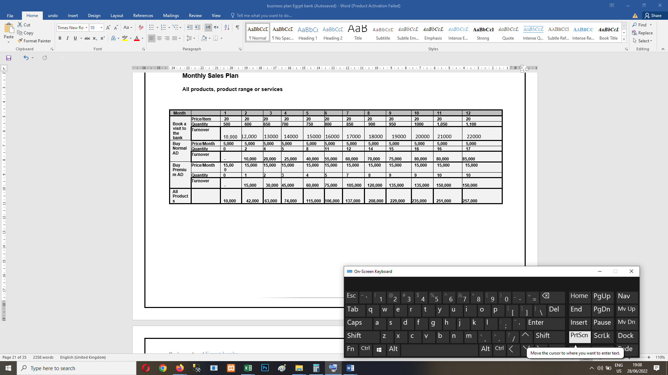

**Monthly Operational Cost Plan**

**Planning is based on the monthly sales plan**

|  |  |  |  |  |  |  |  |  |  |  |  |  |
| --- | --- | --- | --- | --- | --- | --- | --- | --- | --- | --- | --- | --- |
| **Month** | **1** | **2** | **3** | **4** | **5** | **6** | **7** | **8** | **9** | **10** | **11** | **12** |
| **Marketing** | 4,000 | 4,000 | 4,000 |  |  |  |  |  |  |  |  |  |
| **salaries** | 22,500 | 22,500 | 22,500 | 22,500 | 22,500 | 22,500 | 22,500 | 22,500 | 22,500 | 22,500 | 22,500 | 22,500 |
| **Apartment rent** | 5,000 | 5,000 | 5,000 | 5,000 | 5,000 | 5,000 | 5,000 | 5,000 | 5,000 | 5,000 | 5,000 | 5,000 |
| **Subscriptions** | 333 | 333 | 333 | 333 | 333 | 333 | 333 | 333 | 333 | 333 | 333 | 333 |
| **Web App Needs** | 333 | 333 | 333 | 333 | 333 | 333 | 333 | 333 | 333 | 333 | 333 | 333 |
| **= total operational Cost** | **32,166** | **32,166** | **32,166** | **28,166** | **28,166** | **28,166** | **28,166** | **28,166** | **28,166** | **28,166** | **28,166** | **28,166** |

## **2.15 Cash Flow Plan**

**Monthly cash flow plan**

|  |  |  |  |  |  |  |  |  |  |  |  |  |  |
| --- | --- | --- | --- | --- | --- | --- | --- | --- | --- | --- | --- | --- | --- |
| **Month** | **Pre-Operation** | **1** | **2** | **3** | **4** | **5** | **6** | **7** | **8** | **9** | **10** | **11** | **12** |
| **Cash beg of the month** | 0 | 29,166 | 36,166 | 75,166 | 135,166 | 210,166 | 326,166 | 433,166 | 571,166 | 780,166 | 1,010,166 | 1,246,166 | 1,498,166 |
| **+ Equity** | 280,000 |  |  |  |  |  |  |  |  |  |  |  |  |
| **+ Loan** | 100,000 |  |  |  |  |  |  |  |  |  |  |  |  |
| **+ Sales** |  | **10,000** | **42,000** | **63,000** | **74,000** | **115,000** | **106,000** | **137,000** | **208,000** | **229,000** | **235,000** | **251,000** | **257,000** |
| **I: Total Cash in** | **380,000** | 39,166 | 78,166 | 138,166 | 209,166 | 325,166 | 432,166 | 570,166 | 779,166 | 1,009,166 | 1,245,166 | 1,497,166 | 1,755,166 |
| **+ investment** | 30,000 |  |  |  |  |  |  |  |  |  |  |  |  |
| **II: Total cash out** | 30,000 | **32,166** | **32,166** | **32,166** | **28,166** | **28,166** | **28,166** | **28,166** | **28,166** | **28,166** | **28,166** | **28,166** | **28,166** |
| **I – II Cash at the end of the month** | **350,000** | **7,000** | **46,000** | **106,000** | **181,000** | **297,000** | **404,000** | **542,000** | **751,000** | **981,000** | **1,217,000** | **1,469,000** | **1,727,000** |

## **2.16 Profit Margin**

**Monthly Estimation of Net Profit**

|  |  |  |  |  |  |  |  |  |  |  |  |  |
| --- | --- | --- | --- | --- | --- | --- | --- | --- | --- | --- | --- | --- |
| **Month** | **1** | **2** | **3** | **4** | **5** | **6** | **7** | **8** | **9** | **10** | **11** | **12** |
| **I. Total Sales** | **10,000** | **42,000** | **63,000** | **74,000** | **115,000** | **106,000** | **137,000** | **208,000** | **229,000** | **235,000** | **251,000** | **257,000** |
| **II. Total Cost** | **32,166** | **32,166** | **32,166** | **28,166** | **28,166** | **28,166** | **28,166** | **28,166** | **28,166** | **28,166** | **28,166** | **28,166** |
| **I – II Profit (Before tax)** | (22,166) | 9,834 | 30,834 | 45,834 | 86,834 | 77,834 | 108,834 | 179,834 | 200,834 | 206,834 | 222,834 | 228,834 |
| **Less: Income tax (22.5%)** | 0 | 2,213 | 6,938 | 10,313 | 19,538 | 17,513 | 24,488 | 40,463 | 45,188 | 46,538 | 50,138 | 51,488 |
| **Net Profit/Loss After Tax** | (22,166) | **7,621** | **23,896** | **35,521** | **67,296** | **60,321** | **84,346** | **139,371** | **155,646** | **160,296** | **172,696** | **177,346** |

## **2.17 Opening Balance**

|  |  |  |  |
| --- | --- | --- | --- |
| **Assets** | **Value** | **Liabilities and equity** | **Value** |
| **Fixed Assets:**  **Equipment**  **Total Fixed Assets**  **Current Assets:**  **Cash and bank**  **Total Current Assets** | 30,000    **30,000**  350,000  **350,000** | **Equity**  **Long-Term Liabilities:**  **Family Loan**  **Total Long-Term Liabilities**  **Current Liabilities:**  **Total Current Liabilities** | **280,000**  100,000      **380,000**  **0** |
| **Total Assets** | **EGP 380,000** | **Total Liabilities and Net Worth** | **EGP 380.000** |

**Opening Balance of My Business**

## **2.18 SWOT**

**Strengths**

* High service levels
* Highly automated systems
* IT/software expertise
* Easy access to capital and funding
* Solid financial reserves
* Effective sales and service culture
* Focus on internal marketing
* Team-based culture
* Clear segments targeted effectively
* Clear value proposition
* Effective CRM program
* Good understanding of the customer journey
* Strong share-of-customer
* Broad product range
* Attractive store design/layout
* Highly convenient locations
* Clear positioning
* Seen as having strong corporate social responsibility
* Easy-to-use apps

**Weaknesses**

* Poor cost efficiencies
* Mixed quality staff
* Targeting price elastic markets
* No distinct product features
* Undifferentiated products
* Limited engagement from marketing communications
* Have to price under the market
* No consumer connection to the brand
* Limited online advertising experience
* Limited social media success
* No expertise in creating engaging online content
* No real relationships with online “influencers”
* Broad competitive set

**Opportunities**

* Leverage our big data
* Develop a customer relationship culture
* Attract new customers through special offers
* Shift to a customer-centric marketing outlook
* Target more price inelastic markets
* Expand our product mix
* More clearly differentiate our product offering
* Broaden our geographic reach
* Build relationships with influencers
* Expand our number of stores/outlets
* Strengthen/clarify our value proposition
* Build online engagement with our brand
* Advertise on online comparison websites
* Build/acquire digital marketing expertise
* Creating more engaging social media content
* Become a disruptive innovator

**Threats**

* Becoming a market laggard or a me-too player
* Declining unit margins
* Rising fixed costs
* Consumers becoming more price sensitive
* Becoming a me-too player, due to product mix
* Excessive cost of big data
* Inability to grow the customer base long-term
* Poor ratings on review websites
* Being perceived as slow and outdated
* Aggressive price cutting
* Growing competitive set
* Many emerging new entrants
* Breach of data/privacy issues
* Disruptive technology
* High levels of inflation
* Online fraud
* Uncertain market conditions

# **CHAPTER THREE: SYSTEM ANALYSIS**

## **3.1. Introduction:**

It is a process of collecting and interpreting facts, identifying the problems, and decomposition of a system into its components. System analysis is conducted for the purpose of studying a system or its parts in order to identify its objectives. It is a problem solving technique that improves the system and ensures that all the components of the system work efficiently to accomplish their purpose. Analysis specifies what the App system should do.

## **3.2 Requirements gathering:**

In the business environment, it is required to have an effective way of market research to understand what a customer wants and how to be successful over competitors. We needed to focus on how to make the users to achieve their goals. The Requirements gathering process helped in understanding the needs of a customer, especially in the IT industry.

There are several different requirement gathering techniques that can be used. Several tools and techniques are used by the stakeholders and business analyst to facilitate this process and capture the exact and detailed requirements. The Requirements gathering techniques should help in breaking down Requirements and Gathering into digestible steps thereby providing instructions to complete each step.

Requirements analysis is a team effort that demands a combination of hardware, software and human factors engineering expertise as well as skills in dealing with people. Here are the main activities we involved in our app system requirement analysis:

### **3.2.1 User requirements:**

**The system allows that:**

The functional requirements specify all the activities and operations that take place in the system, the following are general functional requirements that exist in our system

Our site gives the possibility for people to take an interest in riding a calf and encourage them to do so. Through the site, people can:

* View all banks and banks details
* View and compare bank tariffs
* View and compare bank offers
* Book bank visit
* View CBE news
* View and book bank treasury

**- Non-Functional requirements**

It’s characteristics that must be existed on the system to be satisfaction for customers that include the following:

1. **Performance:**

Depending on the internet speed, the page is loaded; also, we put in consideration to decrease the quality of images and animations to ease the loading of the page so it would take the mini- mum time response.

1. **Portability:**

The system can run on any web browser that supports HTML5 and CSS3.

1. **Accessibility**:

Our users will be able to access their accounts in an easy way by entering their username and password. And it should be easy to access because:

1) The application will be web-based and can be accessed from any device that has internet connection.

2) The application will have a mobile-based version that enables to use it out door “future works”.

1. **Availability:**

This website will be available to use and help users to carry out their operations conveniently.

1. **Maintainability**:

The website will be designed in a maintainable manner. It will be easy to incorporate new requirements in the individual modules.

1. **Accuracy:**

That the system should provide accurate results, this is achieved by:-

1) Use URL technique.  
2) The database will be up to date.

1. **Security:**

That the system should be able to protect the data and resources by protecting the:

* Privacy of the users.
* Protect privacy & integration of the system response to users.

1. **Usability:**

That is the system should be easy to use, this is achieved by displaying the system in a user friendly way.

1. **Maintainability**:

Maintainability describes how well the system can be kept functional and how well it can be changed.

1. **Recovery**:

Recovery is the ability for a system to prepare and respond to a disaster.

1. **Capacity and scalability:**

The capacity is the amount of resources made available to the system, and scalability is the ability of the system to make use of this resource.

## **Usecase diagram**

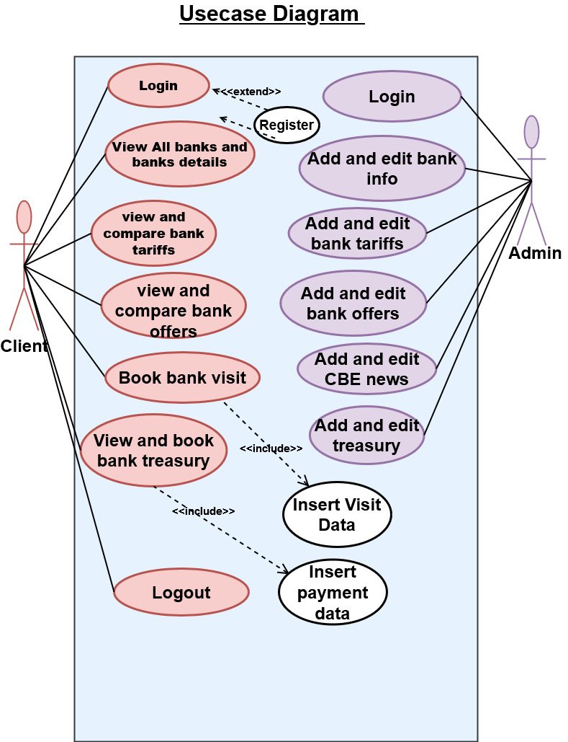

* 1. **Sequence diagram**

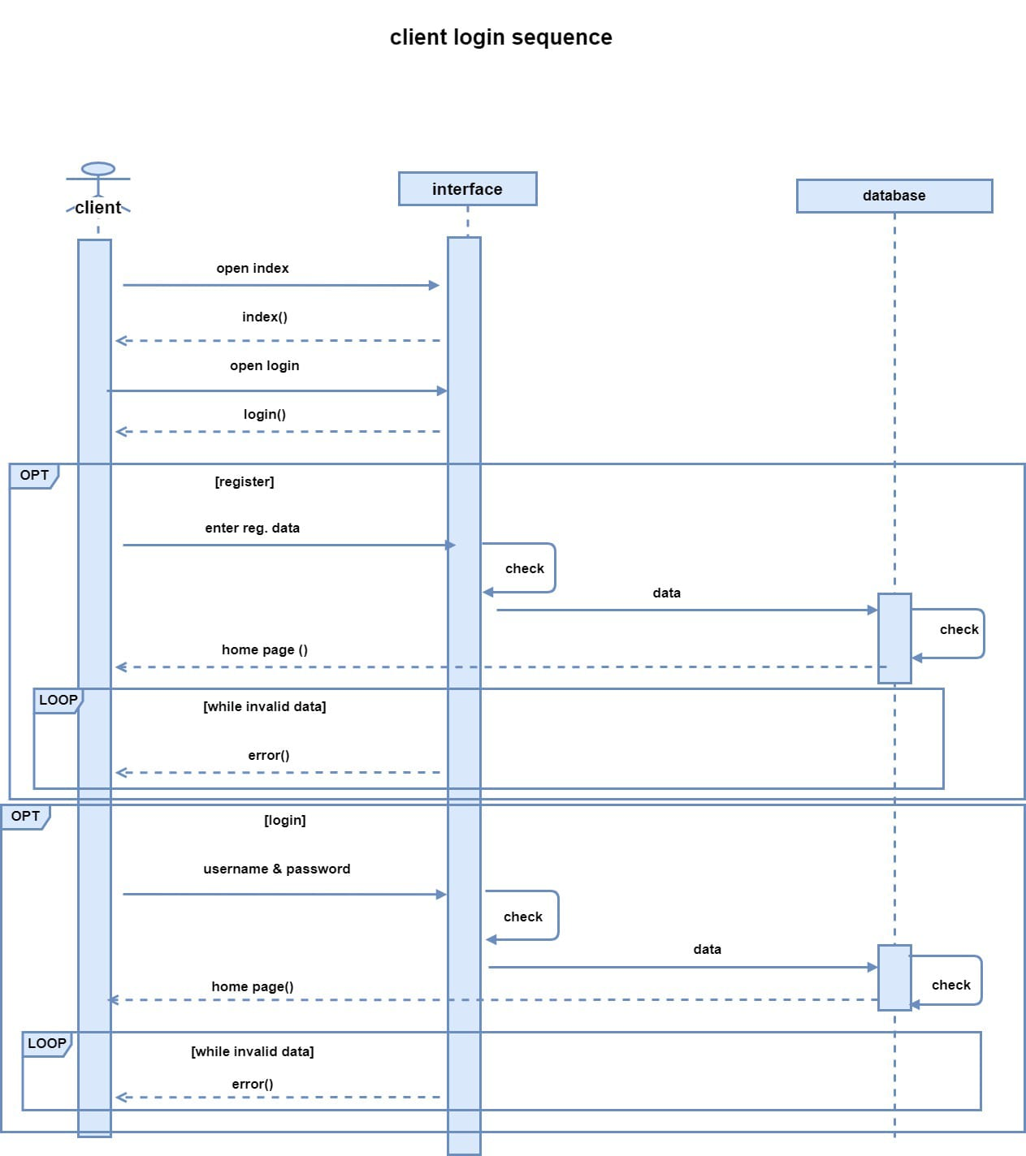

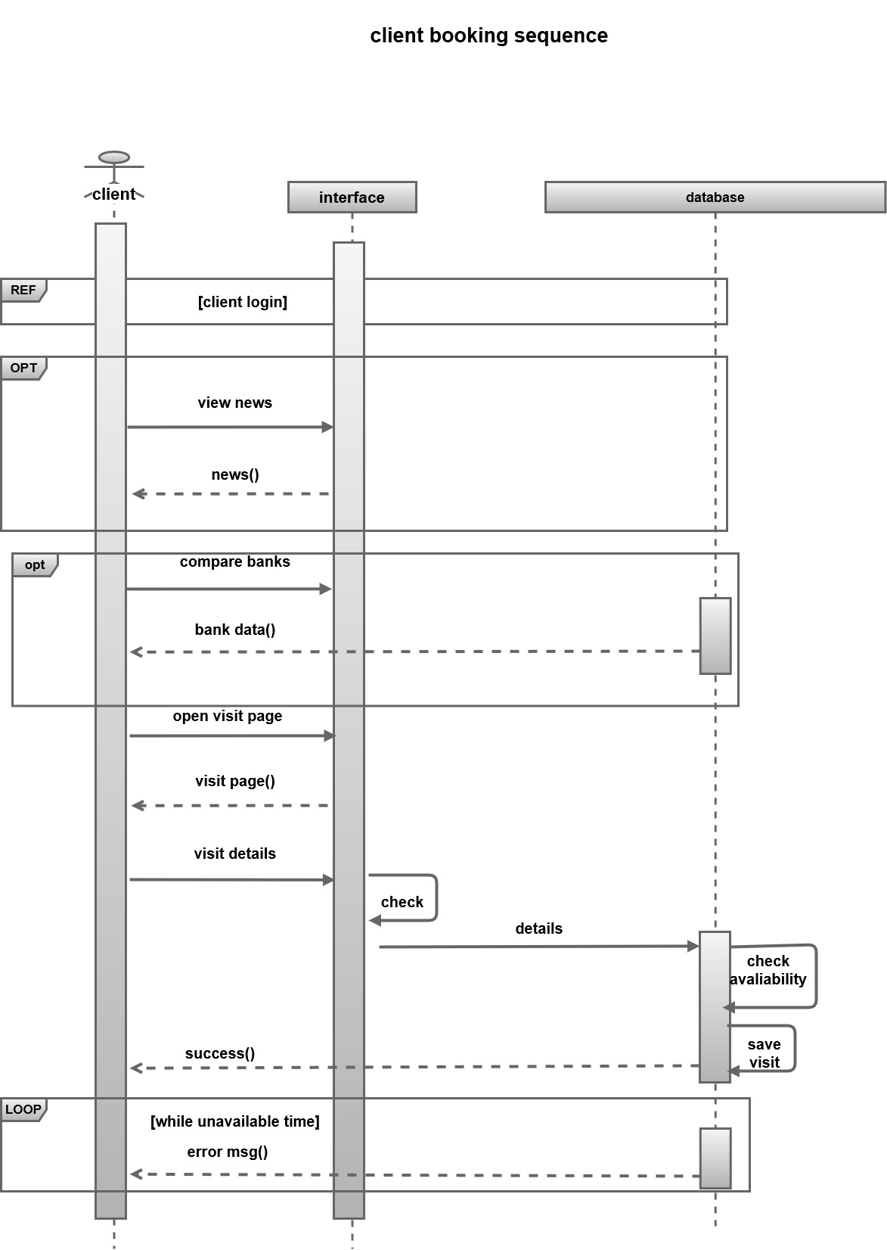

# 

# **CHAPTER FOUR: SYSTEM DESIGN**

## **4.1 Introduction**

System design is the process of defining the elements of a system such as the architecture, modules and components, the different interfaces of those components and the data that goes through that system. It is meant to satisfy specific needs and requirements of a business or organization through the engineering of a coherent and well-running system.

Systems design implies a systematic approach to the design of a system. It may take a bottom-up or top-down approach, but either way the process is systematic wherein it takes into account all related variables of the system that needs to be created—from the architecture, to the required hardware and software, right down to the data and how it travels and transforms throughout its travel through the system. Systems design then overlaps with systems analysis, systems engineering and systems architecture.

## **4.2 ERD**

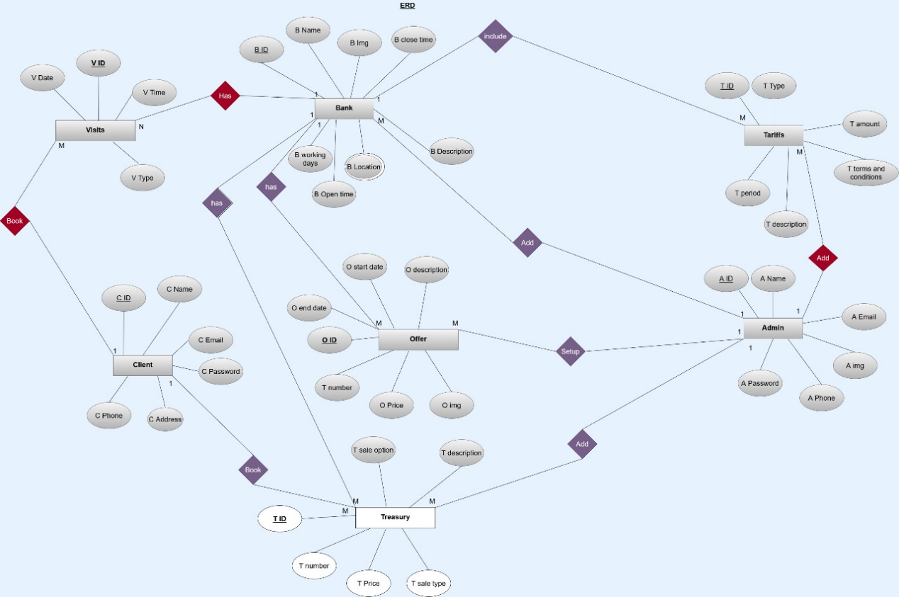

## **4.3 Activity diagram**

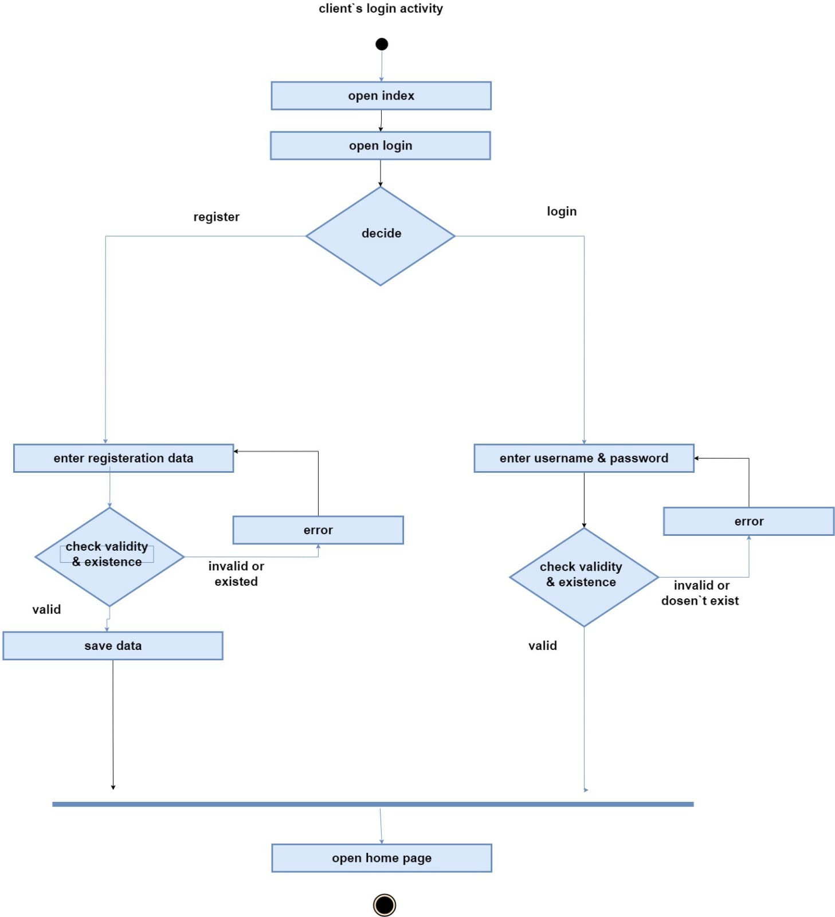

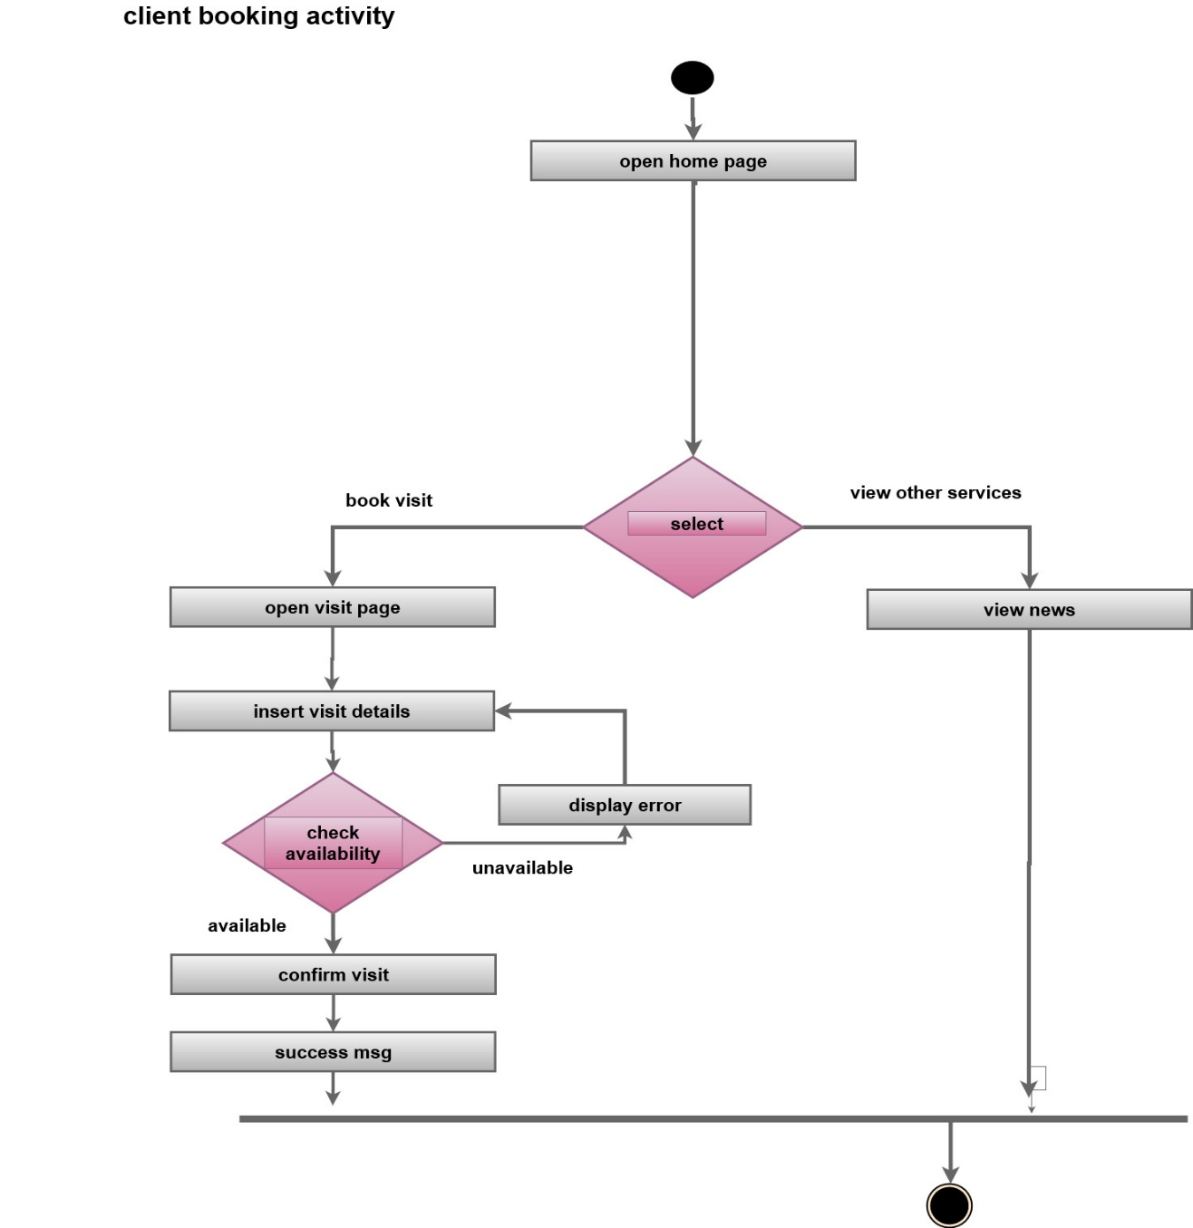

**4.6 Mapping**

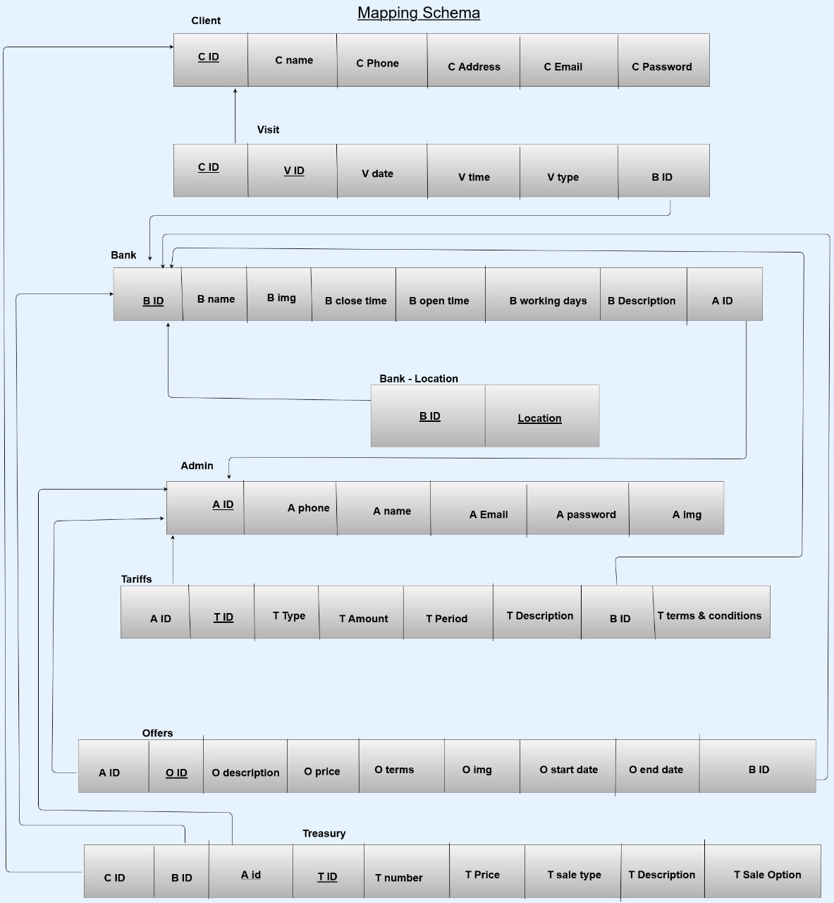

## **4.5 Sitemap**

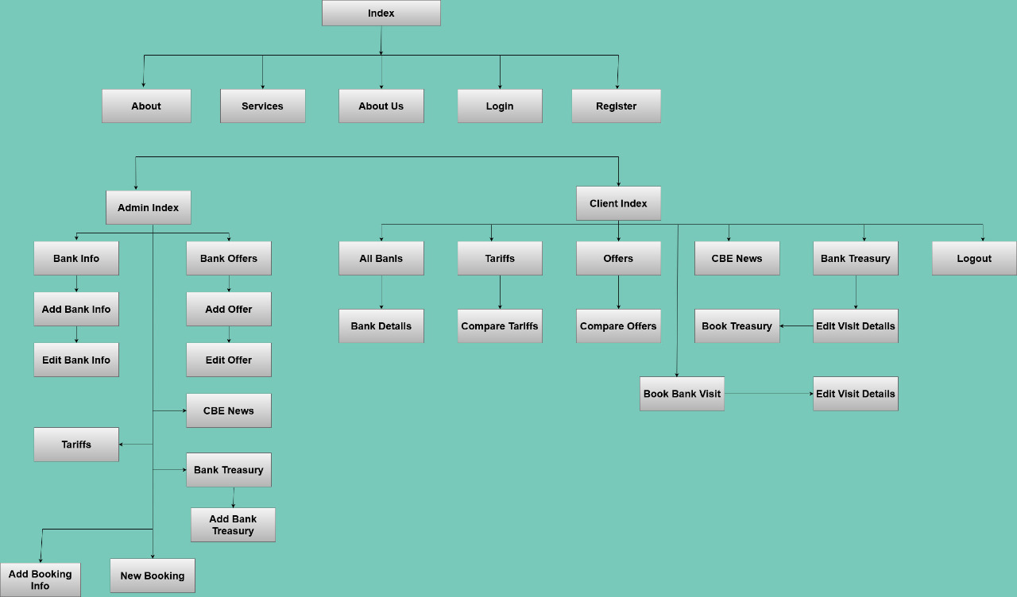

# **CHAPTER FIVE: SYSTEM IMPELENTATION**

## **5.1 Introduction to System Implementation**

A user interface is the part of the system with which the users interact. It includes the screen displays that provide navigation through the system, the screens and forms that capture data, and the reports that the system produces (whether on paper, on the Web, or via some other media).

**Primary methods used in the interface design include prototyping and simulation.**

Typical human–machine interface design consists of the following stages: interaction specification, interface software specification and prototyping:

* Common practices for interaction specification include user-centered design, persona, activity-oriented design, scenario-based design, and resiliency design.
* Common practices for interface software specification include use cases, constrain enforcement by interaction protocols, intended to avoid use errors.
* Common practices for prototyping are based on interactive design based on libraries of interface elements

## **5.2 Screenshots of user interface**

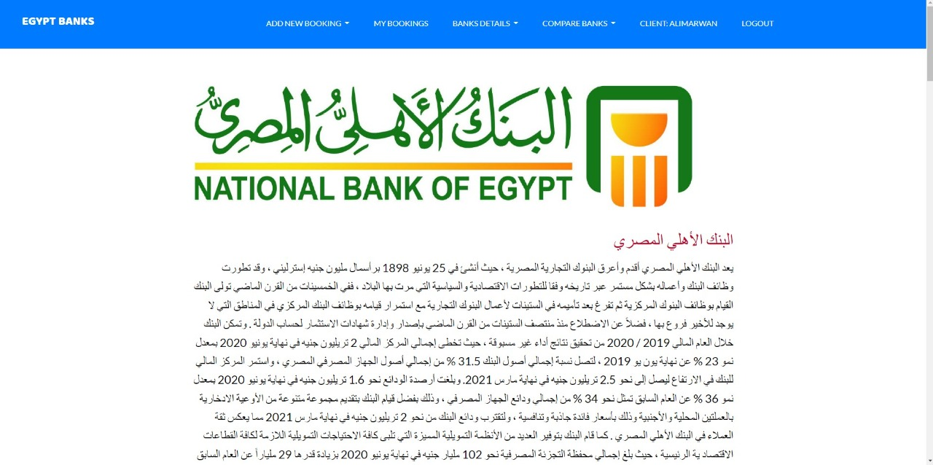

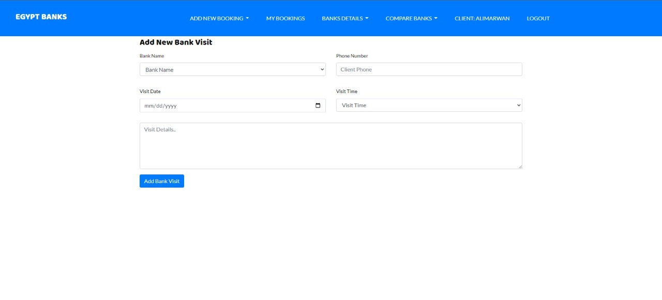

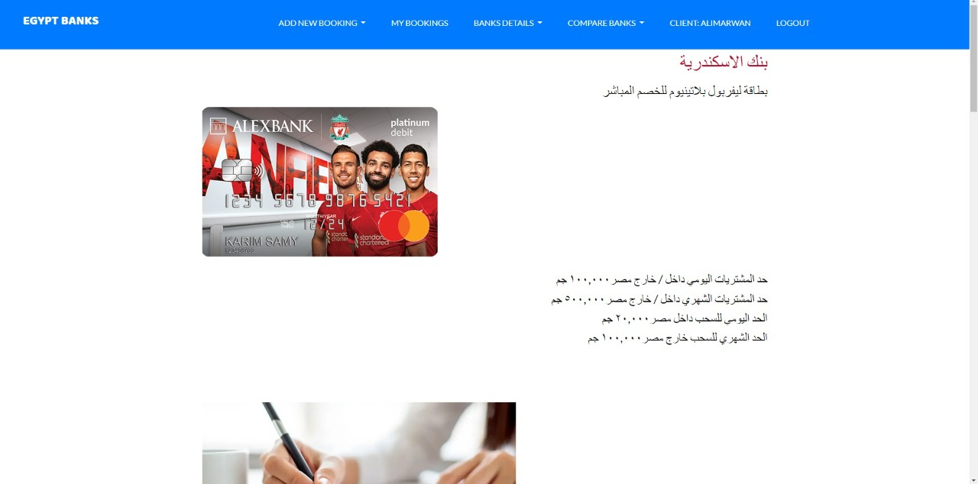

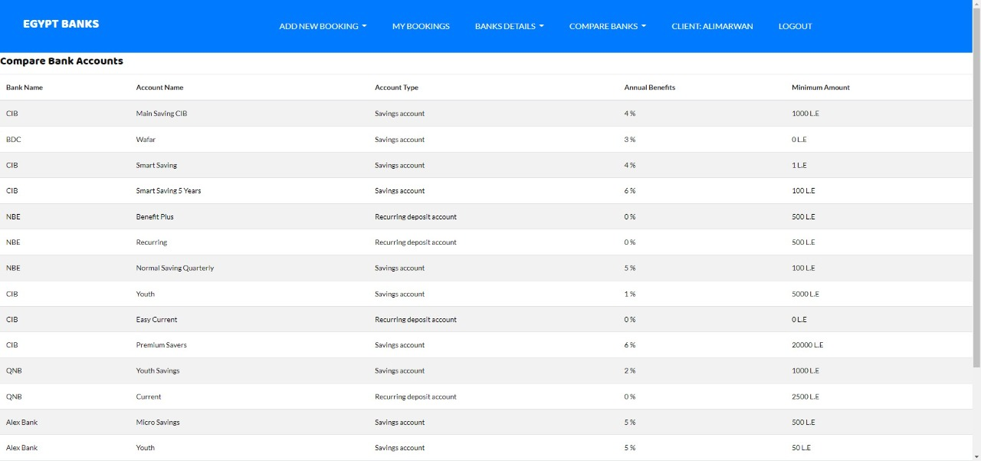

# 

# 

# 

# 

# 

# 

# 

# 

# 

# 

# **CHAPTER SIX: SYSTEM TESTING**

## **6.1 Testing scenario**

It’s a part of system testing where we put predictions for the future actions and what is the precondition in each scenario to clarify a certain problem and test it

* Login scenario

Preconditions: user must open the web app

1.0 user Enter his Credentials.  
2.0 System checks credibility of credentials.

3.0 System retrieves check result.  
4.0 System Display user page

**Alternative flows**

1.1 User enter wrong credentials  
1.1.1 User display error message

* add client scenario

Preconditions: user must be logged

1.0 user Enter customer`s valid data  
2.0 System checks validity.

3.0 System retrieves check result.  
4.0 System Display message

**Alternative flows**

1.1 User enter invalid data

2.1.1 system display error message

* + 1. system ask user to re-enter valid data

**6.2 Testing coding**

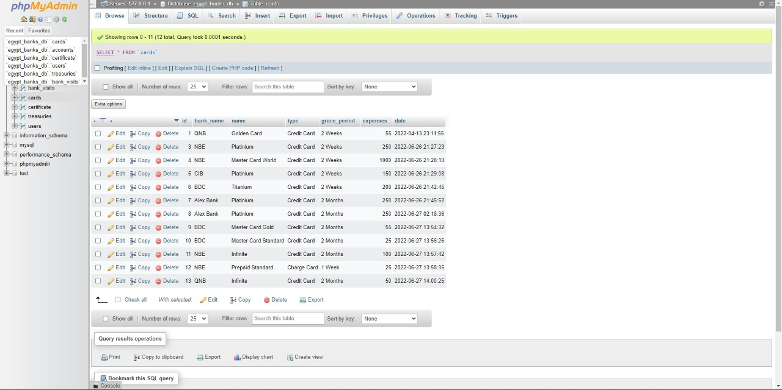

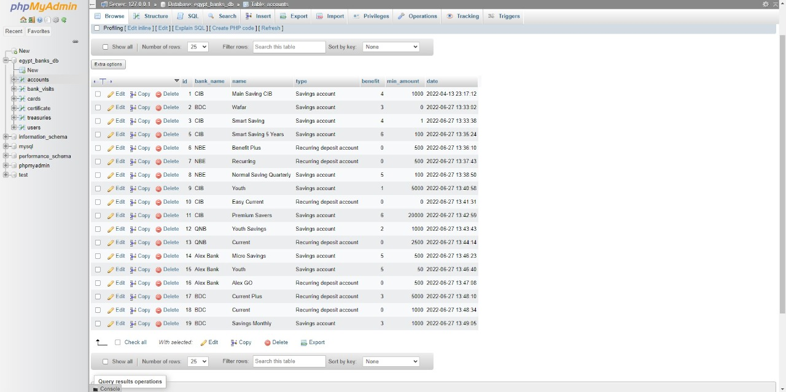

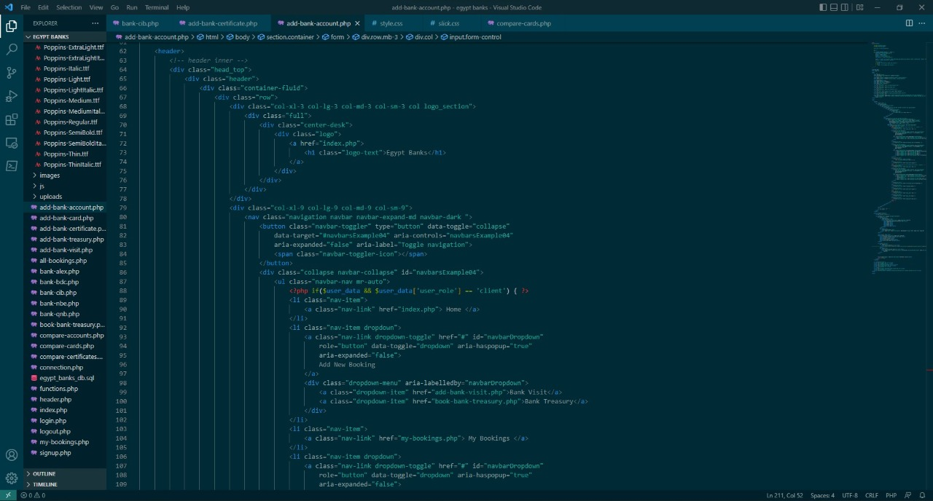

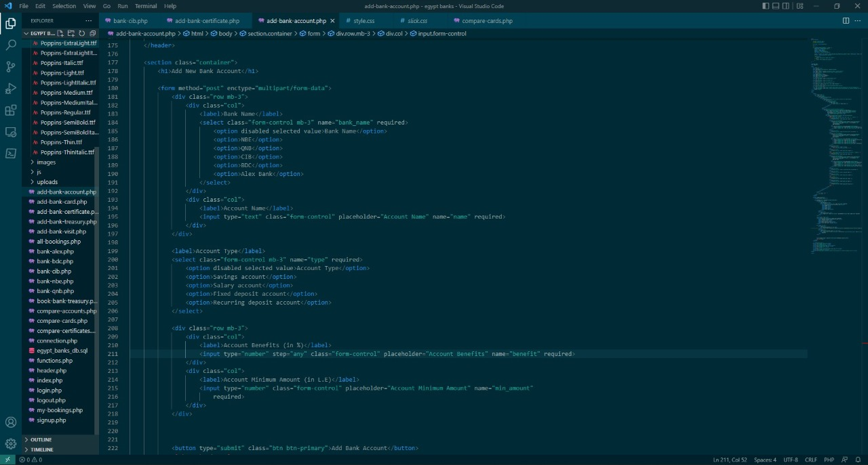

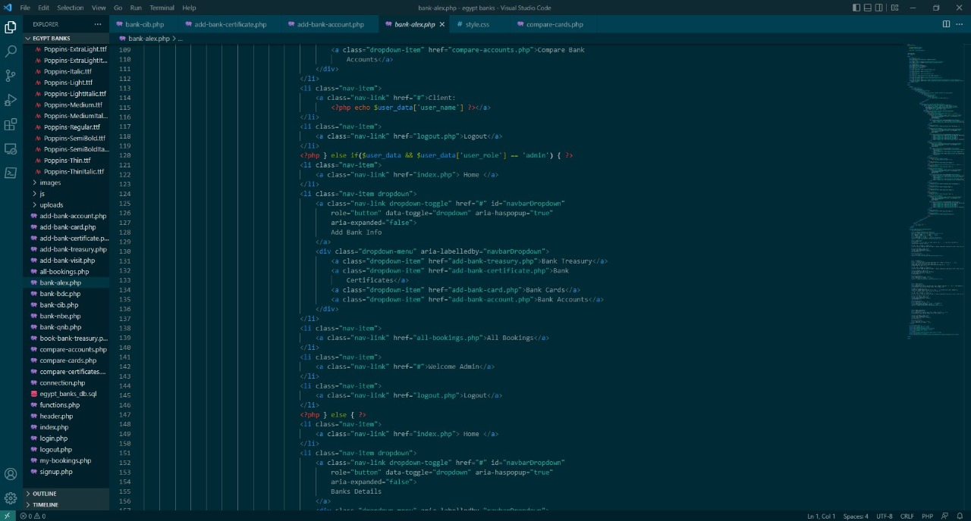

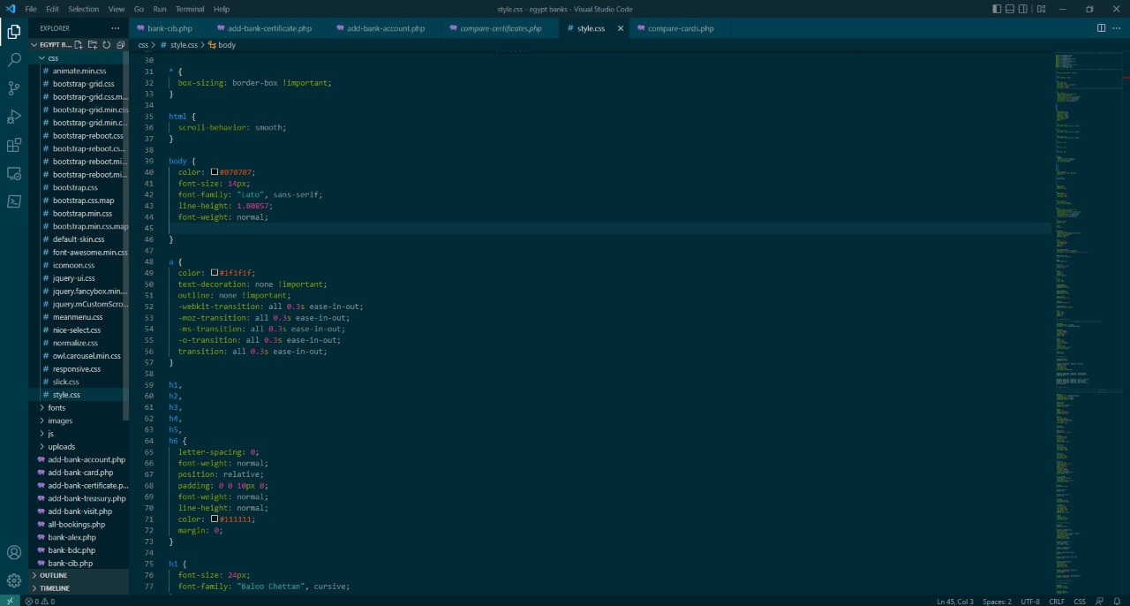

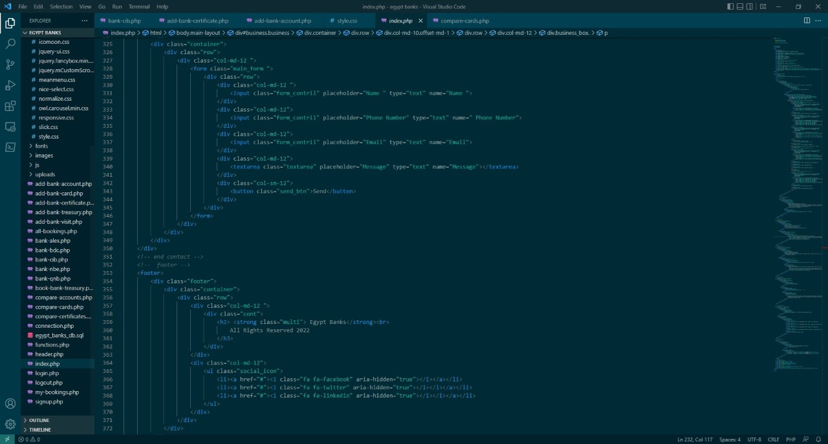

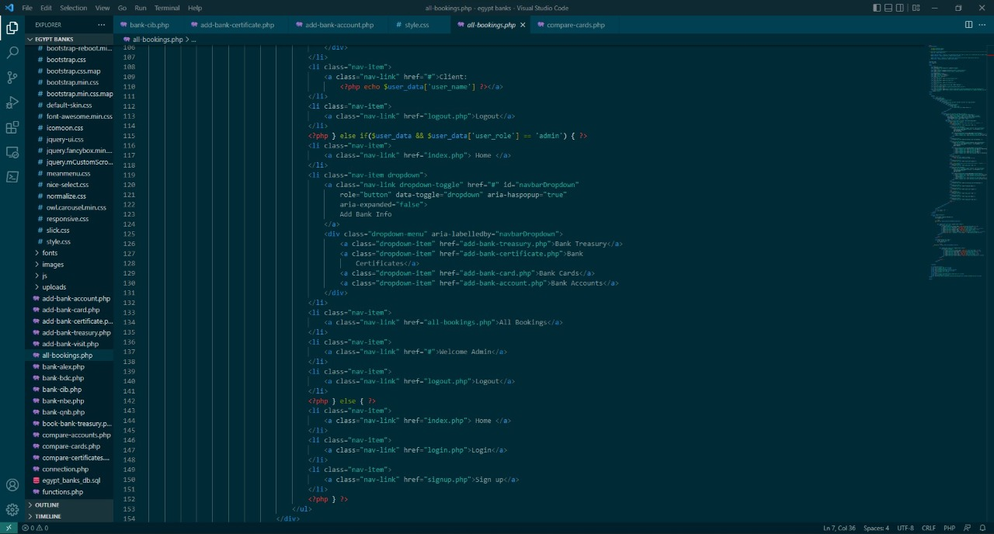

# **CHAPTER SEVEN: CONCLUSION &FUTURE WORK**

## **7.1 Conclusion:**

Our site gives the possibility for people to take an interest in riding a calf and encourage them to do so. Through the site, people can:

* View all banks and banks details
* View and compare bank tariffs
* View and compare bank offers
* Book bank visit
* View CBE news
* View and book bank treasury

.

.

## **7.2 Future Plans:**

1. Make mob application
2. Increase our target of web app
3. Display more functions in wep app
4. Make our app more secure
5. Make offers for our clients to encourage to use our app

# **REFERENCES**

**Books references:**

* + Andrew Whalley- Strategic Marketing -1st Edition 2010
* David Mckean – IT Management
* David Sklar- Learning Php – Oreilly Media-First Eddition, 2016
* System Analysis and Design Assoc. prof. Ayman E.Khedr
* Know About Business, Module 9: How to Elaborate One’s Own Business Plan

## **Websites References:**

* **https://W3school.com**
* **https://W3C.com**
* **https://Codeacademy.com**
* **https://thenewboston.com**
* **https://tradingeconomics.com**
* **https://codepen.com**